The Cat that Walked by Himself (after R. Kipling)
Narrator: Many-many years ago all animals were wild. The Dog was wild, and the Horse was wild, and the Cow was wild, and the Sheep was wild, and the Pig was wild – as wild as could be. They lived in the Wet Wild Woods. The Man was wild too till he had met the Woman.
Woman: I don’t like living in your wild ways. Let’s find a dry cave. It will be our home.
Man: Sure, my darling. And I will hunt a lot and we’ll have a lot of food. But now I’m tired and I want to sleep.
Woman: OK, and I’ll make a fire.
Narrator: In the Wet Wild Woods all the wild animals gathered together. They saw the light of the fire and they wondered what it could mean.
Horse: Oh, my Friends and my Enemies, why have the Man and the Woman made that great light in that great Cave?
Dog: I’ll go and look. I think it is good. Cat, come with me.
Cat: No, I’m the Cat who walks by himself. I will not come with you.
Dog; Then we can never be friends again.
Cat: Why don’t I go and look too?
Woman: Here comes the first! Wild thing out of the Wild Woods, what do you want?
Dog: Oh, my Enemy and Wife of my Enemy, what is this that smells so good?
Woman: Taste and try. It’s a bone.
Dog; Please, give me another.
Woman: Help my Man to hunt and guard the Cave at night and I will give you as many bones as you need.
Cat: Ah, This is a very wise woman but she is not as wise as I am!
Dog: Oh, my Friend and Wife of my Friend, I will help your Man to hunt and I will guard your Cave.
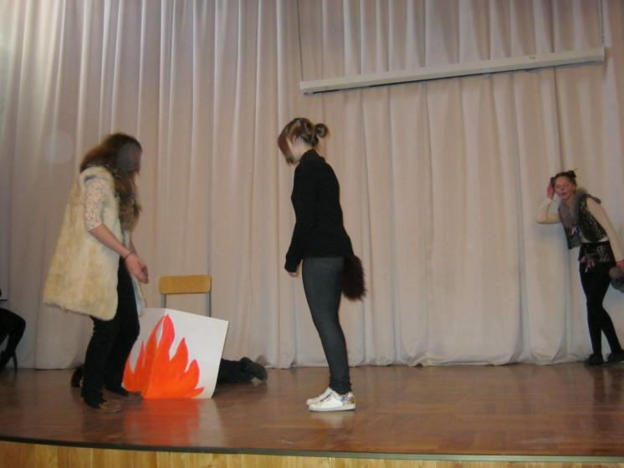
Cat: Ah, That is a very silly Dog!
Man: What is Wild Dog doing here?
Woman: His name is not Wild Dog, but the First Friend and he will be our Friend for always and always. Take him with you to hunt.
Horse: I will go and look why the Wild Dog hasn’t returned. Cat, come with me.
Cat: No, I’m the Cat who walks by himself. I won’t come with you.
Woman: Here comes the second. Wild Thing out of the Wild Woods, What do you want?
Horse: O my Enemy and Wife of my Enemy, where is Wild Dog?
Woman: You didn’t come for Wild Dog, but for this nice grass.
Horse: That is true. Give it to me , please!
Woman: Then bend your head and wear what I give you, and you will eat wonderful grass three times a day.
Cat: Ah, this is a clever woman but se is not so clever as I am.
Horse: Ah, my Mistress and Wife of my Master! I will be your servant.
Cat: Ah ,that is a very silly Horse!
Man: What is Wild Horse doing here?
Woman: His name is not Wild Horse but the First Servant because he will carry us from place to place for always and always. Ride on his back when you go hunting.
Cow: Why hasn’t the Horse returned? I will go and look. Cat, come with me.
Cat: No, I’m the Cat who walks by himself. I won’t come with you.
Woman: Here comes the third. Wild Thing out of the Wild Woods, what do you want?
Cow: O my Enemy and Wife of my Enemy, where is the Wild Horse?
Woman: You didn’t come for Wild Horse . I’ll give you wonderful grass if you give me your milk.
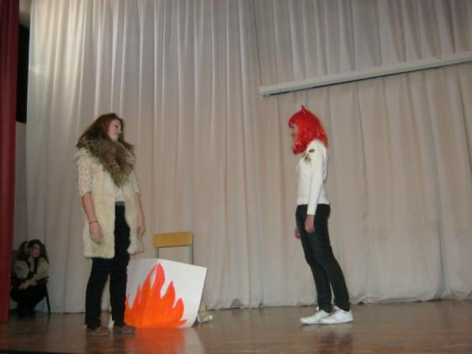

Cat: What a silly Cow!
Man: What is Wild Thing doing here?
Woman: Her name is Giver of Good Food. She will give us warm milk for always and always and I will take care of her.
Cat: O my Enemy and Wife of my Enemy! Where is Wild Cow?Woman: Wild Thing out of the Wild Woods, go back to the Woods. We don’t need more friends or servants in our Cave.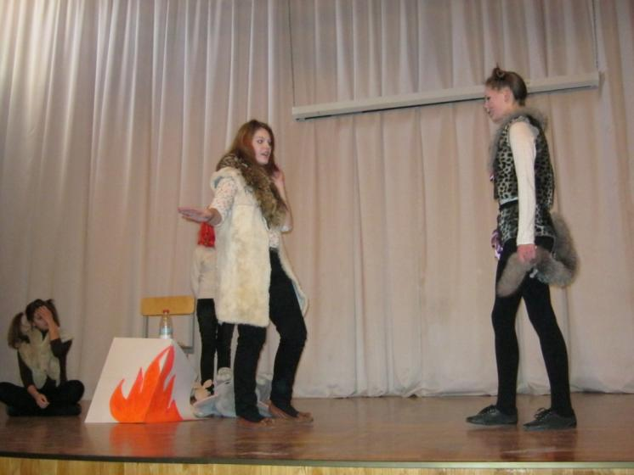
Cat: I’m not a Friend and I’m not a Servant. I’m a Cat who walks by himself and I wish to come into your Cave.
Woman: Go away and walk by yourself!
Cat: But I want to sit by the fire and drink warm milk. You shouldn’t be so cruel with me. You are so wise and so beautiful.
Woman: I know I’m wise but I don’t know I’m beautiful. Let’s make a bargain. If I ever say one word in your praise, you may come into the Cave.
Cat: And if you say two words in my praise?
Woman: I never will, but if I say two words, you may sit by the fire.
Cat: And if you say three words?
Woman: It’s impossible, but if I say three words, you may drink warm milk three times a day.
(A baby cries)
Cat: Ah, now my time is coming! (plays with a baby)
Woman: Oh, thank you , the Wild Thing! I’m so busy!
Cat: You have said one word in my praise!
Woman: OK, you may come into the Cave.
(The baby cries again)
Cat: Tie thread to the stick and pull it along the floor. It will make your baby laugh.
Woman: I’ll do as you’ve said. (The baby laughs) Oh, that was wonderful! You are very clever.
Cat: You’ve said the second word in my praise!
Woman: Now you may sit b the fire. OH, a mouse! I’m afraid of mice!
Cat: I’ll catch and eat it!
Woman: Oh, I’m so grateful to you! A hundred thanks!
Cat: Well, you’ve said the third word in my praise.
Woman: You are so wise. You will have your milk three times a day.
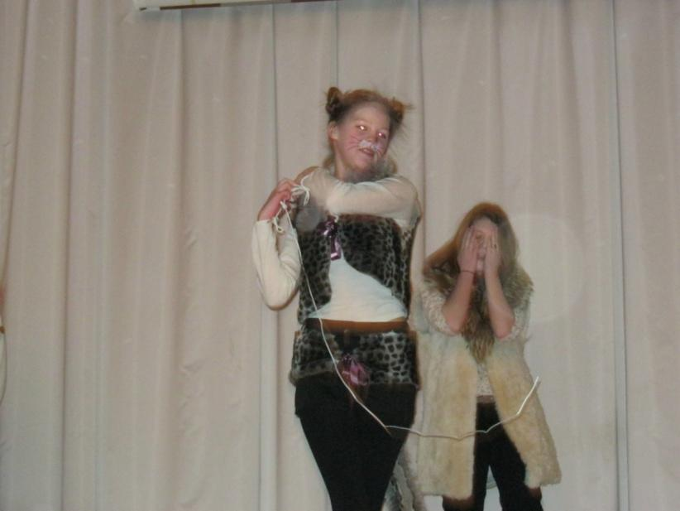
Man: What is the Wild Thing doing here?
Woman: We had a bargain. The Cat will sit by the fire and has milk for always and always.
Man: Now we’ll make our bargain. If you don’t catch mice in the Cave I’ll throw a boot at you and so will all Men do after me for always and always.
Dog: And I will chase you and so will all Dogs do after me.
Woman: Ah, this is a very clever Cat but he isn’t as clever as my Man and the Dog.
Cat: OK, but I will always and always be the Cat who walks by himself.
Narrator: From that day the Cat keeps his side of the bargain. He kills mice, he is kind to babies. But when he has done that, he walks by himself where he wants. All Men throw boots at Cats and all Dogs chase them.
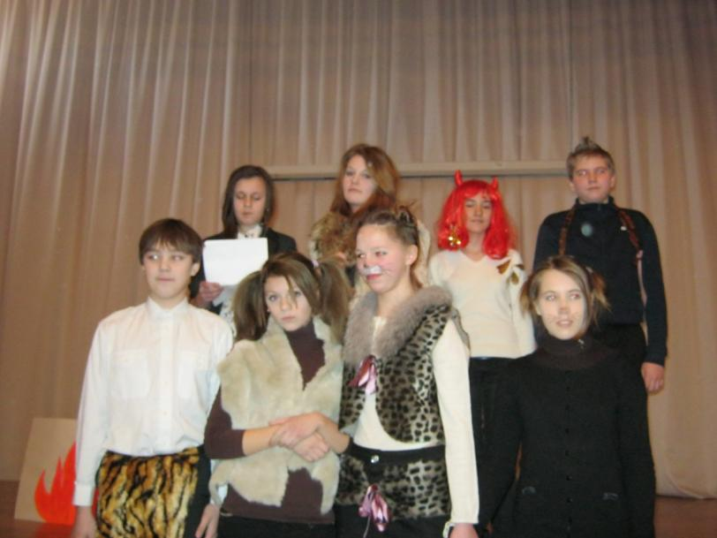

Фотографии
«Приключения Алисы в стране чудес» (Л.Кэрролл)  Сцена: «Безумное чаепитие» | 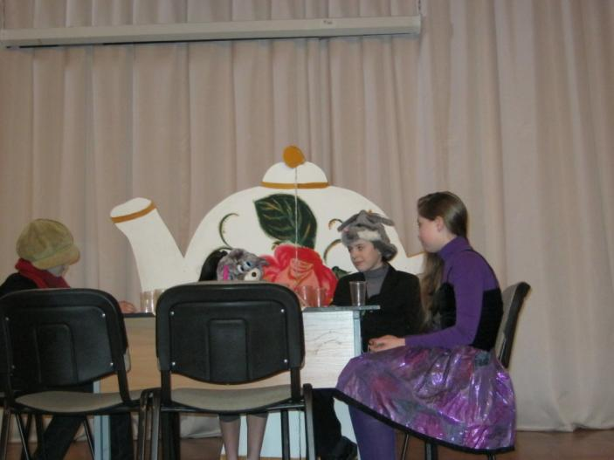
«Приключения Алисы в стране чудес» (Л.Кэрролл)  Сцена: «Безумное чаепитие» | 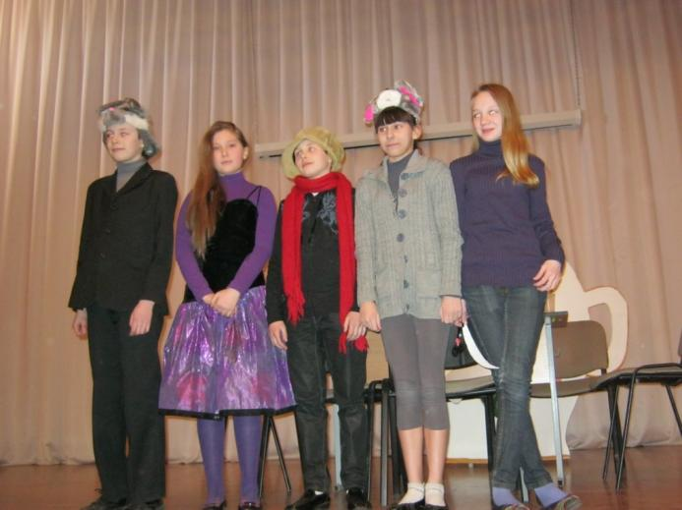
«Приключения Тома Сойера» (Марк Твен)  Сцена: «Том красит забор» | 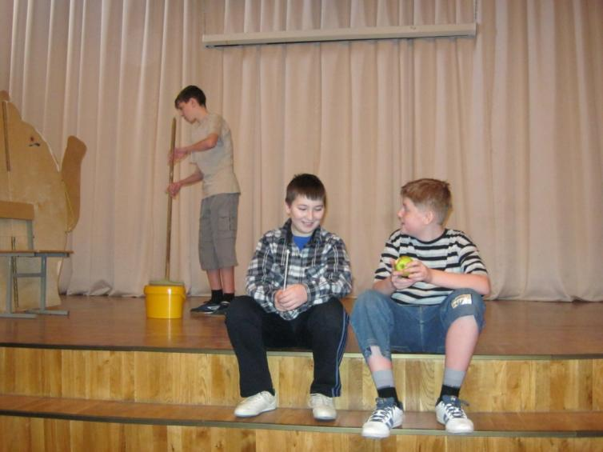
«Приключения Тома Сойера» (Марк Твен)  Сцена: «Том красит забор» | 